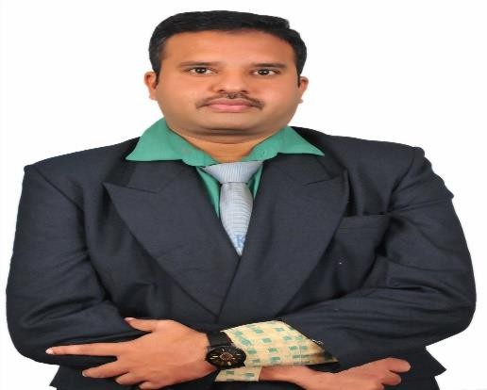CURRICULUM VITAE

**R.IDAYATHULLA**

**11/32,7thCross,KurinjiNagar, Lawspet Pondicherry**

**MobileNo**:**9578315688**

[**EmailId:idayathulla86@gmail.com**](mailto:idayathulla86@gmail.com)

# OBJECTIVE

I intend to establish myself as Software with an integrated business solution provider through a long-time commitment, contributing to the company's growth and inturn ensuring personal growth within the organization. I believe that my technical, functional and communication skills will enable me in facing the challenging career ahead.

To obtain a challenging job to develop the students in developing computer-based Application and to guide

them for their partial fulfillment of Postgraduate Course on Computer Science and Software Engineering.

Also Expecting the Co – Operative institution to do my research (PhD).

# PROFILESUMMARY

* Software Foundation.
* Overall responsibility for the day-to-day operations of the project, Reporting
* Periodically to all the stakeholders,Project Planning and Tracking,Riskanalysis,
* Counter action and Team building and on-site deployment.
* Excellent Interpersonalskills,outstanding problem solving and decision-making Skills
* Strong Interpersonal communication skills.
* Ability to learn new technologies fast.
* Ability to work in team environment emphasizing organizational goals.
* Amiable, analytical and adaptable to new environments.

**Educational Qualification**

|  |  |  |  |  |
| --- | --- | --- | --- | --- |
| **Course** | **Board/University** | **Institution** | **Year of Passing** | **Marks (%)** |
| PhD (PartTime) Computer Science | PRIST (Deemed to be University) | Prist (Deemed to be University),Thanjavur | Pursuing | |
| M.Phil.  (Computer Science) | PRIST (Deemed to be University) | Prist (Deemed to be  University), Pondicherry Campus | September2011  (2010–2011) | 87.5% |
| MCA | ANNA UNIVERSITY | Mailam Engineering College, Mailam | June2009  (2006–2009) | 85% |
| B.SC | THIRUVALLUVAR UNIVERSITY | Islamiah College, Vaniyambadi | April 2006  (2003–2006) | 80% |
| H.S.C | STATE BOARD | Sri.V.D.S Jain Higher Secondary School,  Tiruvannamalai | March2002 | 80.83% |
| S.S.L.C | STATE BOARD | St.Mary’sBoys High School, Vettavalam | March2000 | 85% |

# SOFTWARE SKILLS:

* Knowledge in C,C++,Java
* MSOffice.
* SQL\XML.HTMl
* VISUALBASIC

# TEACHING EXPERIENCES:

★ Arunai Engineering College, Tiruvannamalai from July23 2009 to Sep 02 2015.

★ Shree Raghavendra Arts and Science College, Keezhamoongiladi, Chidambaram

From June 1 2016 to May 2017.

★ PRIST (Deemed to be University) June 2017 to15-4-2021.

★ E.S Arts & Science College, Villupuram15-7-2021 to 30-6-22

★ Dhanalakshmi Srinivasan College of Engineering and Technologies from

11/07/2022 - 05/06/2023.

★ Srinivasan College of Arts &Science (Co-Ed), Perambalur (11-06-2023 to 21-04-2025)

**Best Faculty Award**

★ Software Project Management

★ Design and Analysis of Algorithms

Above Mentioned Papers Got 100% of Results in University Exams.

**Publications Details-**

★ International Journal of Engineering and Advanced Technology-Configure Routing Path Algorithms for Ethernet Topology (Volume-9 Issue-6, August 2020)

★ Annals of the Romanian Society for Cell Biology-Network Management with Reliance on Topology and Generating Paths through the Network Layers (Vol. 25, Issue 3, 2021)

★ Turkish Journal of Computer and Mathematics Education-To send a data from source to destination using secure CPU Architecture Encryption of Return Addresses through Network Topology Algorithm (Received: 10 November 2020; Revised 12 January 2021 Accepted: 27 January 2021)

# MAINPROJECT:

## **TOPIC :** A TREE BASED PEER–PEER NETWORK WITH QUALITY

GUARANTEES

**DESCRIPTION :** One Node to the Another Node to Share the information through

A Network

# PERSONALSKILLS

NAME : R.Idayathulla

## DATE OF BIRTH : 01-05-1985

FATHER NAME : V. Rahamathulla

OCCUPATION : Post Graduate

## MOBILE NO : 9578315688

MARITAL STATUS : Married

PERMANENT ADDRESS : 11/32,7th Cross Kurinji Nagar, Lawspet, Pondicherry

EMAILID : [idayathulla86@gmail.com](mailto:idayathulla86@gmail.com)

STRENGTH : Sincere and perfect in work, Helping nature and Teamwork.